Mohammad Alazmi
Group manager.
The Whit line sensor is a feature of the micro mouse, that gives it ability to follow the white line and dodge any black surface. I analyse the circuit and understanding how the sensor tells the white line from the dark surface.
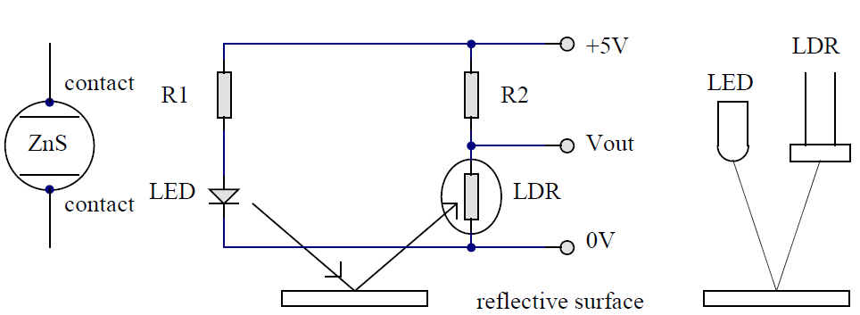
It's based on the LDR that change its resistance with reflected light. In natural situation the circuit with 5V input provide 2.5V in the output, this value of the out pot will change in white line the light fro LED light-dependent resistor will reflect to the LDR and its resistance will reduce dramatically will act as cable with very low resistance as as a result the Vout will reduce. Measuring Vout using multimeter the value was in the range of 1.6V comparing with 2.5V, however, in black surface the reflected light is much less than a white line as a result the resistance of the LDR will increase also the vout increased in range of 3.3V.
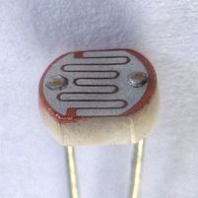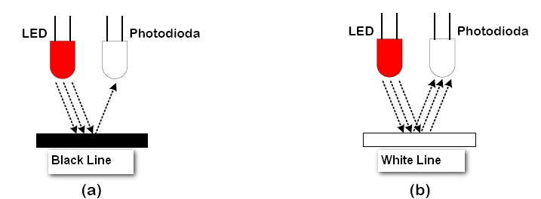
Taking value of the Vout as a reference to the Micromouse will control of its move, by that its mean using 1.6V and 3.3V and programming it using C language, will make its fallow white line by using IF command, After build the circuit I connected it in port B in the micro controller.

